CIS 435 Proj. 3 notes

* Download xampp from google
  + Follow steps to download (make sure it isn’t installed in C: program files)
  + <https://www.youtube.com/watch?v=-f8N4FEQWyY>
* Week 9, Part 1 (1: 41:00) shows how to do php myadmin
  + Follow instructions for a few minutes (make sure to put project folder in htdocs folder which is in the xamp folder)
* To open webpage
  + Start Apache and mysql
* 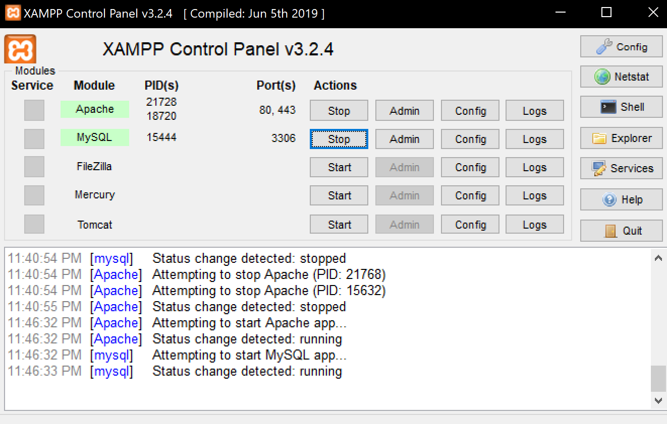
  + Type in <http://localhost/project_starts/tech_support/> to browser
    - This should work correctly if you put the project folder in the correct place (ht docs in xampp folder)

(I showed the website and the windows explorer path)

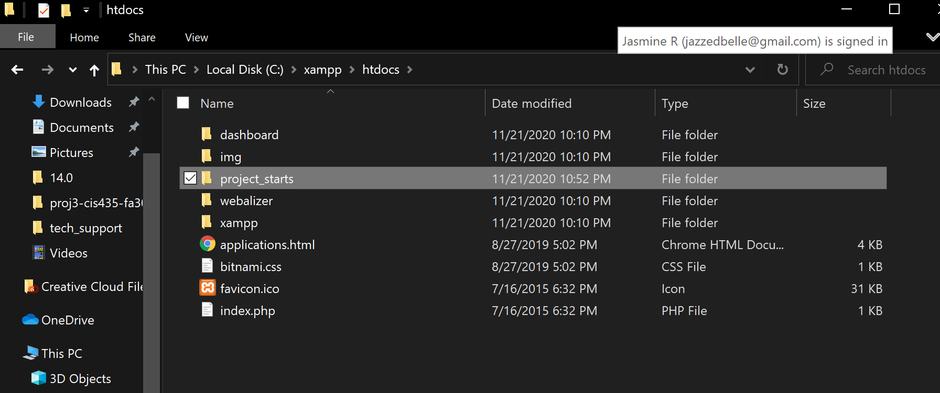

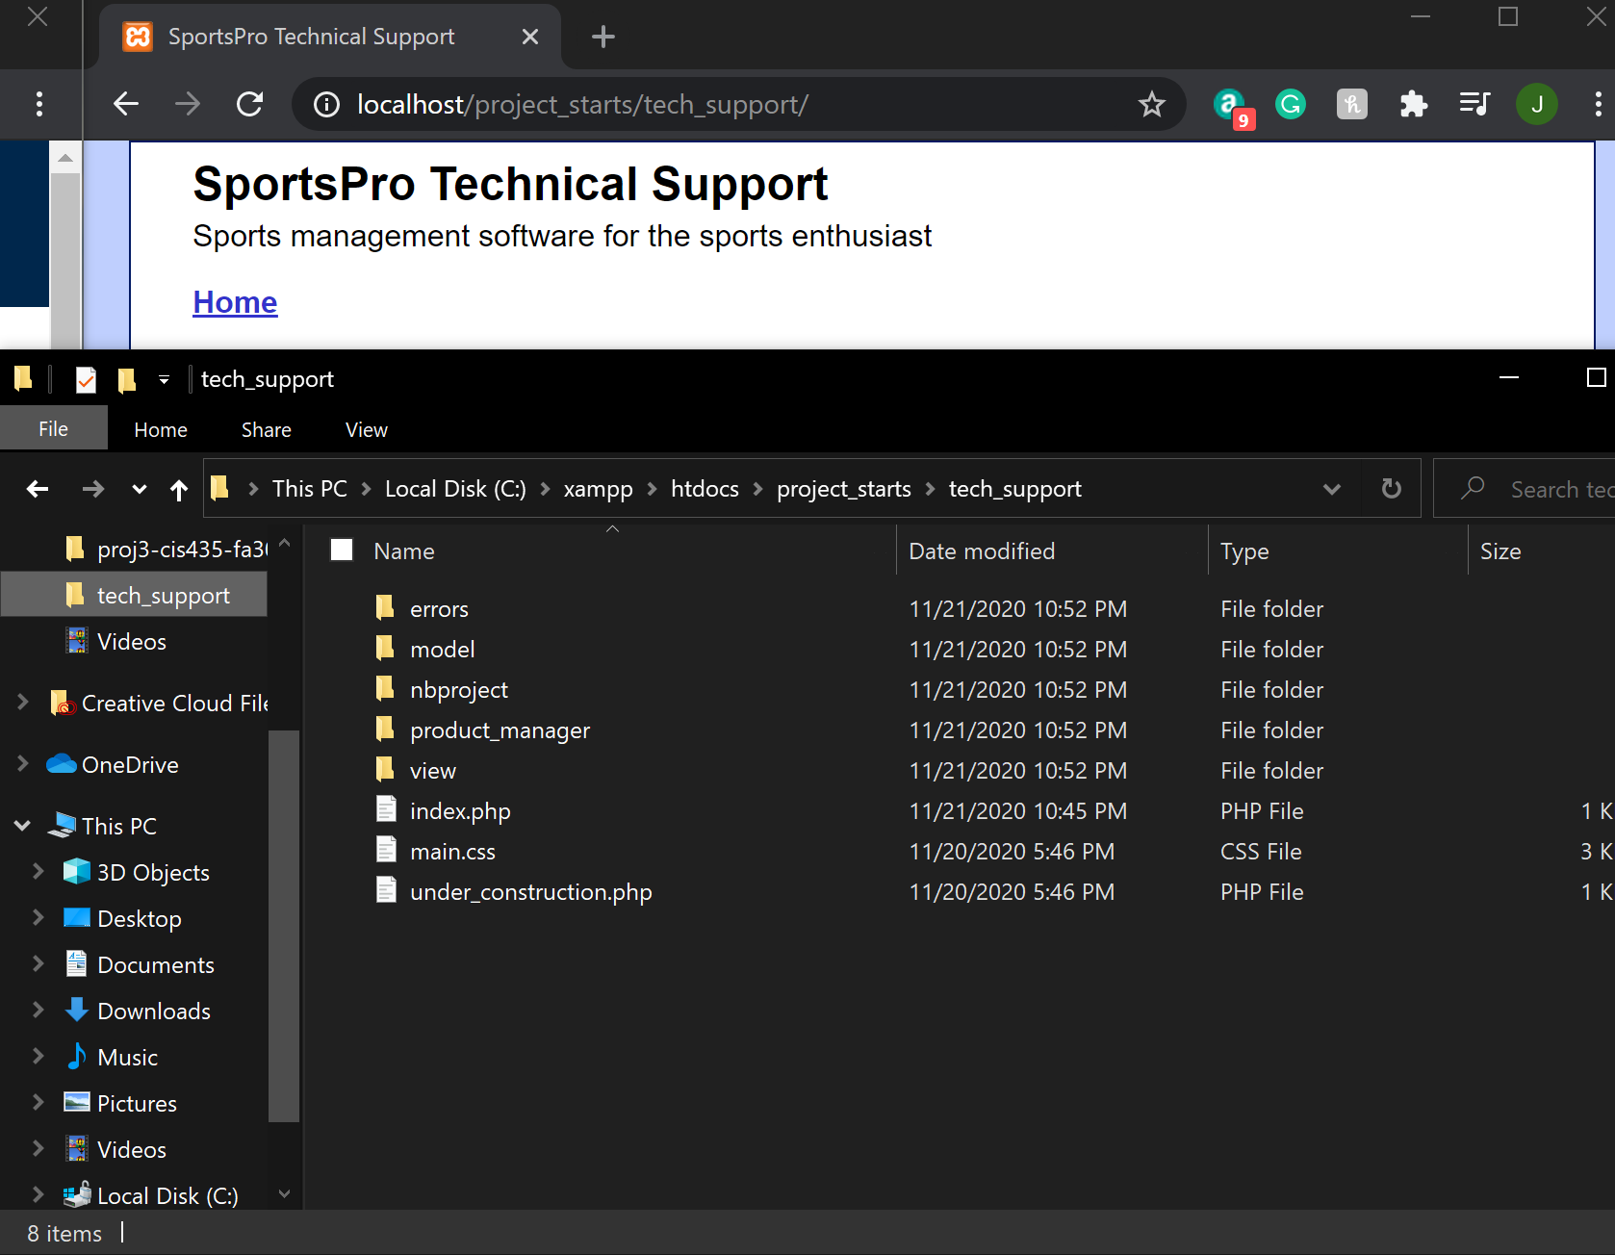

* Phpmyadmin
  + Download software from web
  + Type in <http://localhost/phpmyadmin/> to browser
  + Click on databases tab to see all databases (and create new ones)

**Things we have done:**

**Jasmine**

First commit in github repository

Home link

Partial 6.4 (Register Product)

6.5 (Create Incident)

**Samantha**

6.1 (Manage products)

6.2 (Manage technicians)

6.4 (Register Products)

**Jess**

6.3 (Manage customers)

Testing

Final report